**[PuTTY** & **PuTTYgen** Software are **required]**

How to Download & Install PuTTY? Click –

[**Putty installation steps.pdf**](https://drive.google.com/open?id=1ZmKz0P8S-1DMzcaHZBKhji0C3A3t8nmG)

1. Open “**PuTTYgen**” software
   1. select the *‘type of key to generate’* as “**RSA**”

- Click on "**Load** button

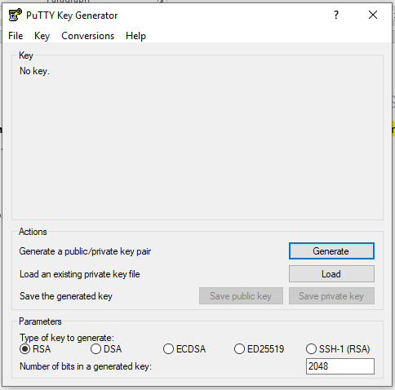

1

2

* 1. Select “**All Types (*.*)**” from file types dropdown –

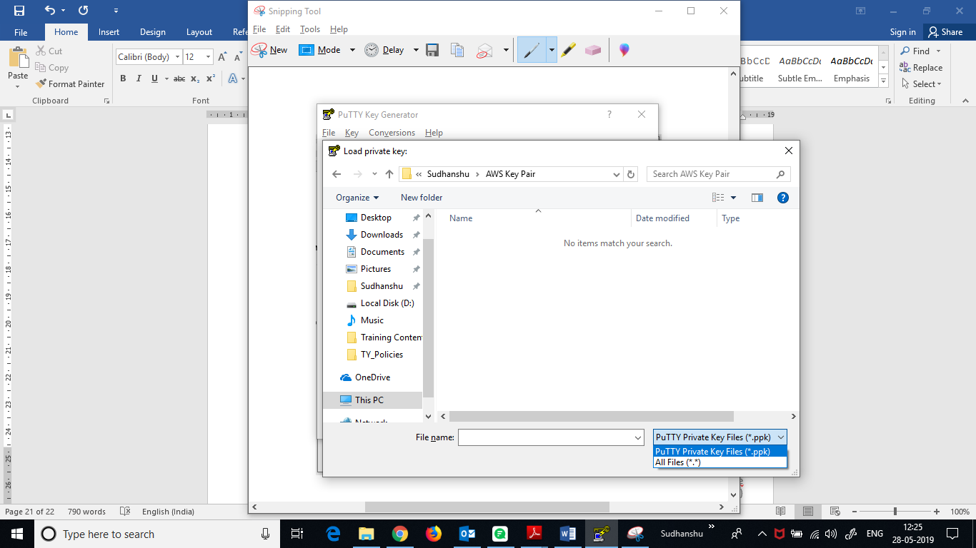

* 1. Browse for “**webserver_ubuntu_key.pem**” file *(downloaded in STEP-**Error! Reference source not found.)*, select it and click on “**Open**” –

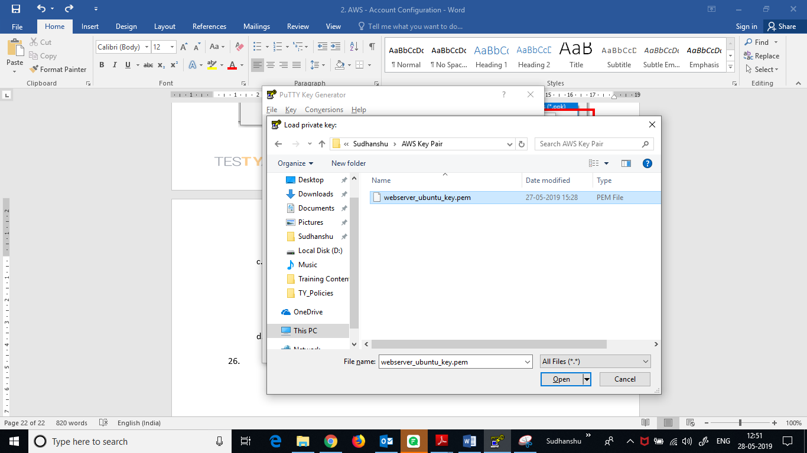

* 1. If “*PuTTYgen Notice*” popup pops up, click on “OK”

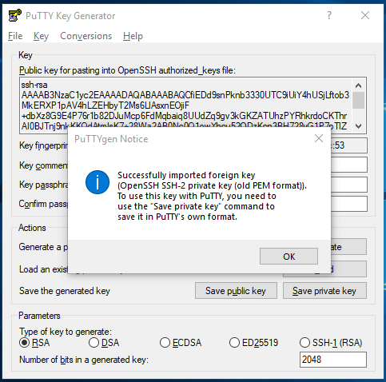

* 1. Click on “**Save private key**” button –

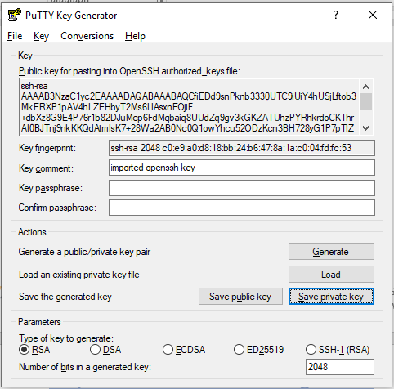

* 1. On ‘*PuTTYgen Warning*’ popup, click on “**Yes**” –

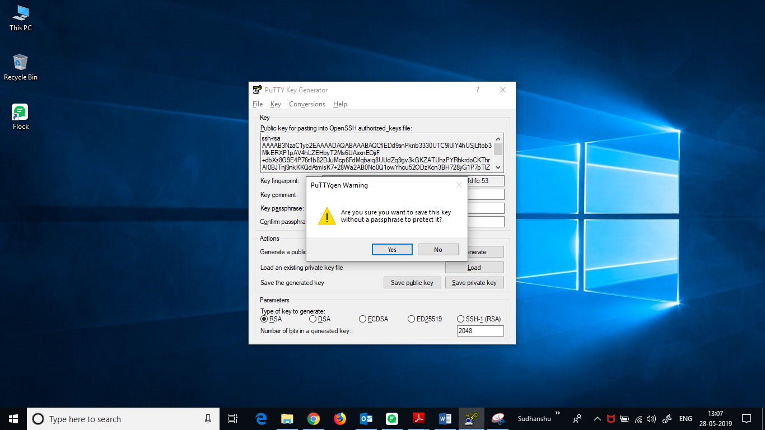

* 1. Save the file by name “**webserver_ubuntu_key**”.  
     (file name with extension will be “**webserver_ubuntu_key.ppk**”)

**[NOTE: - This “.ppk” file is an important file. It is *required to connect to your server (instance)* using PuTTY. So, save this file in a place u can easily remember and also in the drive *other than* your OS installed drive.]**

* 1. **Close** PuTTYgen.

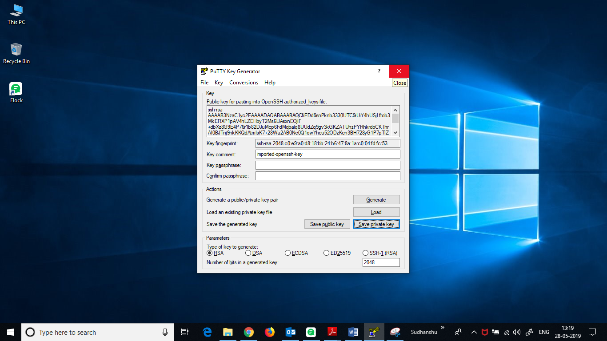

1. Open “**PuTTY**” software.

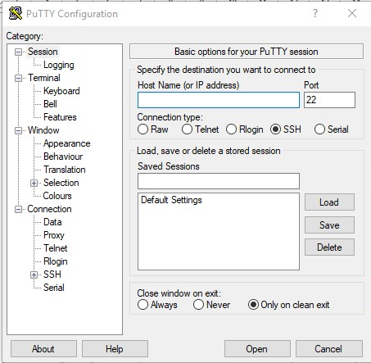

‘Host Name’ can be found in *‘EC2 – Dashboard’* of AWS.

**(Follow Below Steps)**

* 1. Here you need to Enter the **Host Name**. *To find host name, proceed as follows –*
* Login to you AWS Management Console, and go to your **EC2 Dashboard**.  
  (Follow *STEP: 1 – 3* from [**AWS - EC2 configuration steps.pdf**](https://drive.google.com/open?id=11POIvIBCKFd-ZoqwXnH6YbhllzNlncsZ))
* Click on “**Running Instances**”

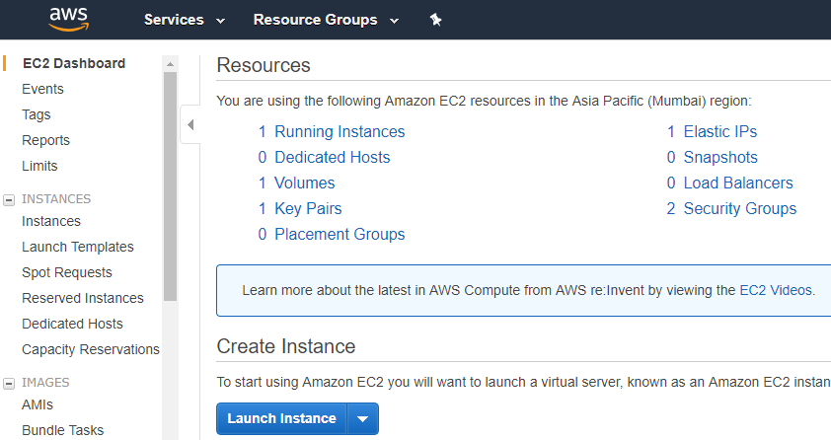

* Select Your ‘*EC2 Instance*’ with which you want to connect –

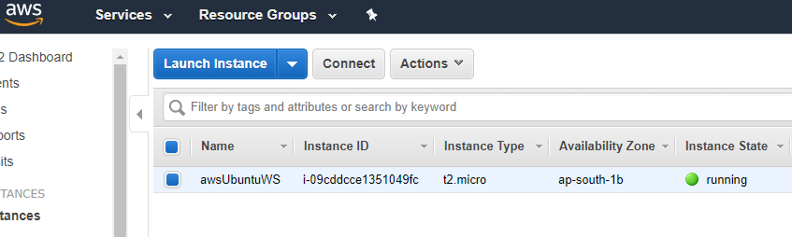

* Click on “**Connect**” button –



* Copy the **URL** *(this will be the host name in PuTTY)* –

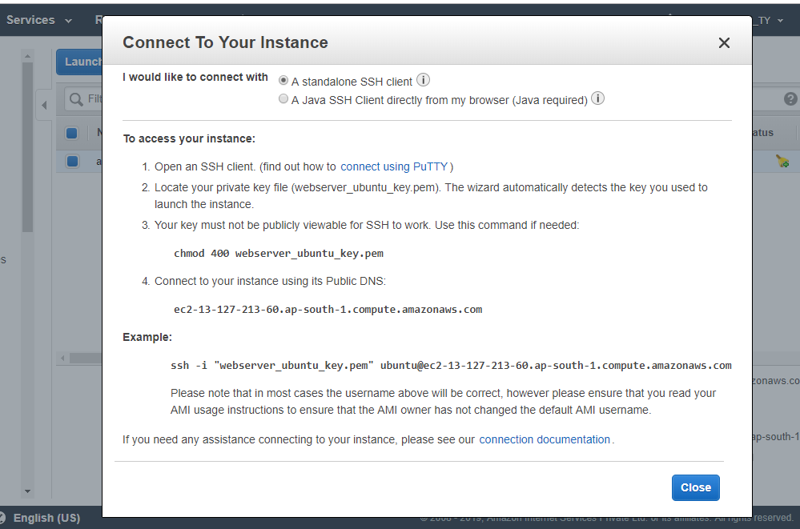

* Go back to PuTTY.
  1. Paste the copied URL in **Host Name** input box –

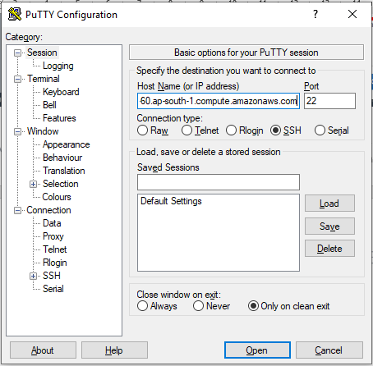

* 1. Enter *“Port no”* **22** and select *‘Connection Type’* “**SSH**”



* 1. Under “**Category:**” Navigation Pane, Expand **Connection** 🡪 **SSH** 🡪 select “**Auth”**

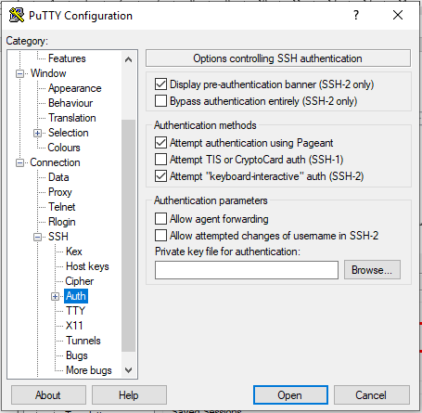

* 1. **Ensure** the checkboxes checked as in below image and click on “**Browse**” button –



* 1. Browse for “**webserver_ubuntu_key.ppk**” file *(generated and saved in STEP-* ***1.g****)*, select it and click on “**Open**” –

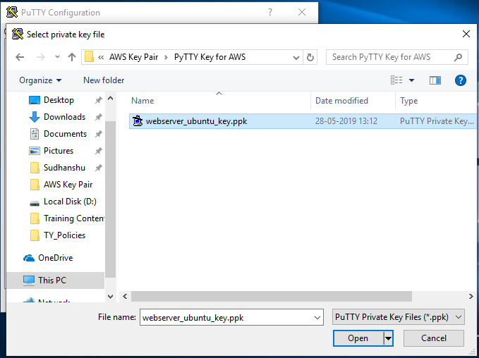

* 1. Click on “**Open**” –

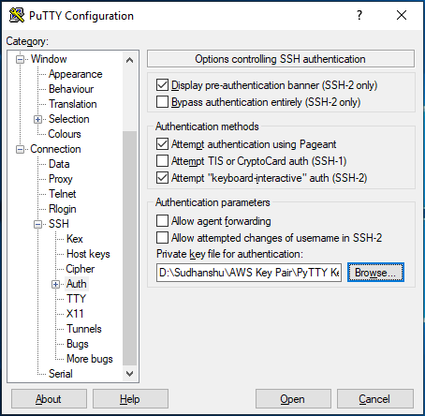

* 1. In the “*PuTTY Security Alert*” dialogue box, click on “**Yes**” button –

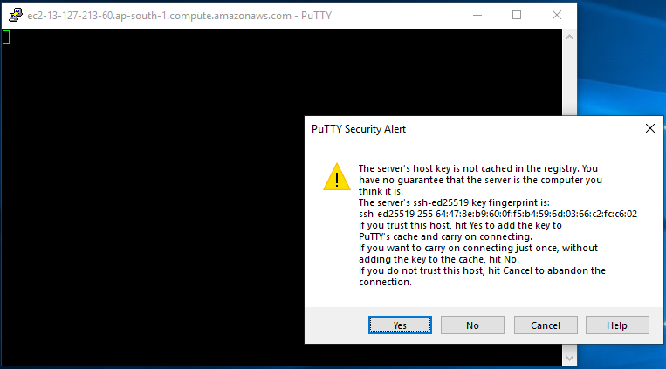

* 1. 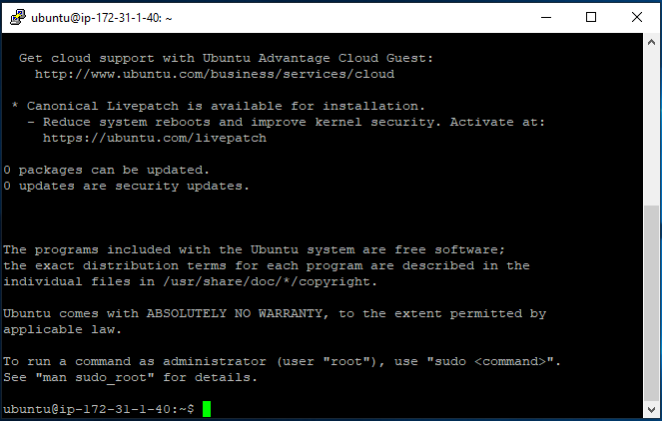**That’s it**. You are now in your Server (EC2 - Instance).